**Realiza Program: Entrepreneurs’ profiles**

**Who was mobilized to sign up to the Program?**

***November, 2022***

Summary

Summary 2

Introduction 3

1. The Mobilization Process 4

What was done during the mobilization process for the REALIZA Program 4

Main challenges and main learnings from the mobilization process 4

2. Candidates’ business profile 4

3. The selected businesses’ profile 9

4. Key strategic considerations for future mobilization 15

Introduction

This report has two main objectives:

1. To describe the female entrepreneurs’ profiles mobilized for the REALIZA Program and understand who expressed interest in enrolling the program;
2. To identify whether new strategies can be developed to mobilize and engage female entrepreneurs for a potential second round of the REALIZA Program.

The data presented was collected during the registration process of the Realiza Program. In August 2022, the MUVA team carried out an evaluation through an internal audit to analyze strengths and weaknesses of the mobilization process. This analysis combined with an in-depth understanding of the entrepreneurs’ profile clarifies potential avenues for improvement and to guarantee greater engagement of entrepreneurs.

1. The Mobilization Process

## 1.1 What was done during the mobilization process of the REALIZA Program

To sign up 6,000 female entrepreneurs, the mobilization process for the Realiza program was held from December 1st of 2021 to February 25th of 2022. Fourmain strategies were used:

1. **Face to Face mobilization with entrepreneurs**: 34 young women were hired and trained as mobilizers (10 in Beira; 10 in Nampula and 14 in Maputo), the mobilizers were organized in groups to cover different geographical areas of the three cities and approach entrepreneurs door to door and through indications.
2. **Online mobilization through social media**: an outreach campaign was held during the mobilization period with key messages dissemination through MUVA’s fakebook page and Instagram
3. **Mobilization through associations/organizations that work with Mozambican entrepreneurs:** institutions working with entrepreneurs in Mozambique were identified and materials were delivered to them for communication through their own channels
4. **Dissemination through radio and television:** Realiza agents and facilitators participated in several radio and television programs to inform about the Realiza Program registration.

During the mobilization process, a dashboard was created to monitoring the data, which allowed the team to respond to challenges in real time, ensuring better results on the field.

## 1.2 Main challenges and main learnings from the mobilization process

The main learnings of this process were:

* **About the engagement of associations and organizations working with Mozambican entrepreneurs**. Alignment with mobilization partners require greater effort to ensure materials are being disseminated.

A recommendation would be to develop a weekly follow up strategy with partners.

* **About Motivational sessions being crucial to ensure participants’ engagement**. This is an important step of the mobilization and cannot be skipped. Having several interactions with potential participants prior to the Program, might be tiring and jeopardize the interest in participating.

A recommendation would be to register more entrepreneurs than needed and invite them to a Motivational session. The ones that come would be more suitable to be randomized.

1. The Candidates’ business profile

The data presented below refers to the business profile of the 5,914 entrepreneurs that registered for the Realiza Program. The source of the analysed data comes from the registration form that they filled out at the time of registration.

## 2.1 About the businesses mobilized

The mobilization process registered 6,003 women in Beira, Maputo and Nampula, of which 5,914 owned a business.

Figure 1: Number of entrepreneurs mobilized that owned a business



From the mobilized entrepreneurs, 2,533 are from Maputo, 1,729 are from Beira, and 1,652 from Nampula.

Figure 2: Distribution of entrepreneurs per city



## 2.2 About business formalization

The vast majority of businesses mobilized were not formalized. Figure 3 shows that in Maputo, 12.4% of entrepreneurs have formally registered their businesses, while in Nampula this number was11.9%, and in the city of Beira, only 9.7% are formal businesses.

Figure 3: Formal and Informal businesses per city



## 2.3 About businesses’ profits

The majority of female entrepreneurs mobilized in all three cities reported profitting less than 5,000 meticais in the last month. Figure 4 shows that In Maputo, 13.6% of entrepreneurs reported profitting more than 10,000 meticais and 22.1% between 5,000 to 10,000 meticais. In the city of Nampula and Beira, the number of entrepreneurs profitting more than 10,000 is similar, 9% and 8.7% respectively. For entrepreneurs that report profitting profitting between 5,000 and 10,000 meticais the difference between the two cities is 12pp: 26.9% of Beira’s mobilized entrepreneurs report profitting between this range while in Nampula only 14.6% reported the same.

Figure 4: How much businesses in each city were profiting



## 2.4 The correlation between years of existence and formalization

When analysing the data about registered and formalized businesses, there seem to be a correlation between years of existence and formalization. Figure 5 shows that while there are formalized businesses that exist between 6-8 years there are none unregistered businesses that exist for more than 6 years. On average, formalized businesses have 4 years of existence while unregistered businesses have 3.

Figure 5:Business formalization and years of existence

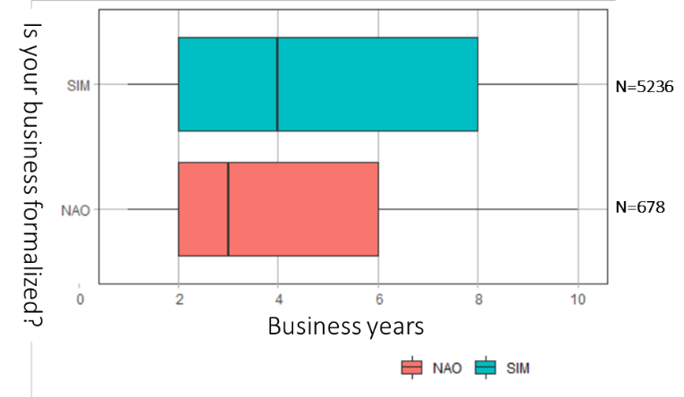

## 2.5 The correlation between years of existence and monthly profit

According to the data, the number of years a business exists seems to be related to their profitability. Mobilized businesses existing for 2-3 years, profit less than 5,000 meticais. Businesses operating between 3-5 years are across the board. Profit does not seem to have any correlation to years of existence in this case.

None of the businesses mobilized operating for more than 5 years profit less than 5,000 and can profit between 5,000 to 10,000 or more than 10,000. Businesses that exist for more than 8 years are the ones that profit more than 10,000 meticais.

Figure 6: Years in business and Monthly profit

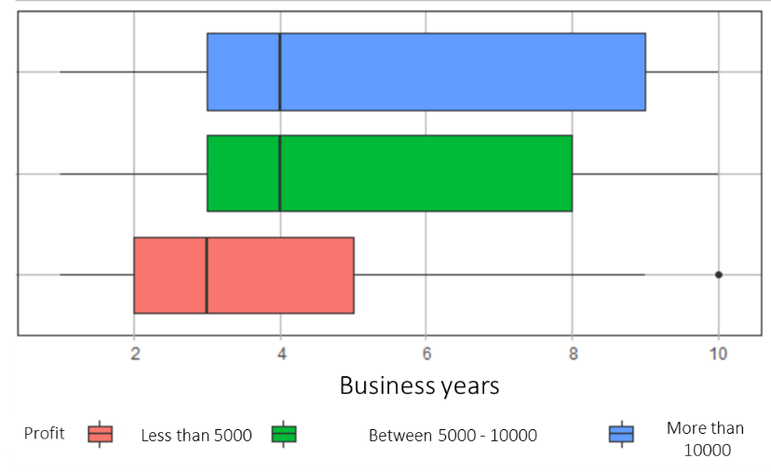

## 2.6 Workers and profit

Businesses that profit more, employ more. Entrepreneurs that signed-up to the Program were asked if they employed people in the last month. Employment was described as wage workers, not waged workers, full-time jobs or part time jobs.

On average, 42.3% of the total businesses mobilized have workers and 58% of the entrepreneurs work alone in their business. Figure 7 shows that 21% of the mobilized businesses profiting less than 5,000 meticais per month have workers, while 79% does not employ workers. For the businesses that profit between 5,000 to 10,000 per month, this percentage seems to be more balanced. 58% of the businesses does not employ any workers while 42% do employ workers. The businesses that profit more than 10,000 employ more people. 64% report to have hired workers in the last month, while 36% reported not hiring.

Figure 7: The amount of employees and monthly profit

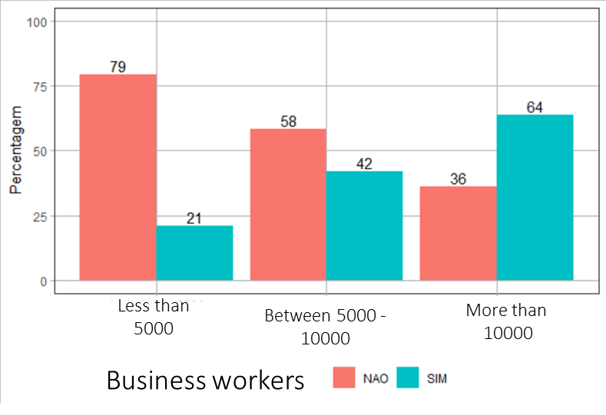

## 2.7 Social Media and Monthly Profit

In general, social media is very much used by entrepreneurs for sales, 45% of them use it for this goal. Social media is more used by entrepreneurs that profit more than 10,000 meticais per month. This might be an indicative of the type of business and the level of digital literacy of the entrepreneur.

Figure 8 shows that for businesses that profit less than 5,000 and between 5,000 and 10,000 meticais per month, the percentage is very similar. Approximately 60% of entrepreneurs do not use social media for sales, while 40% do use it.

Figure 8: Percentage of businesses that use social media and their monthly profits

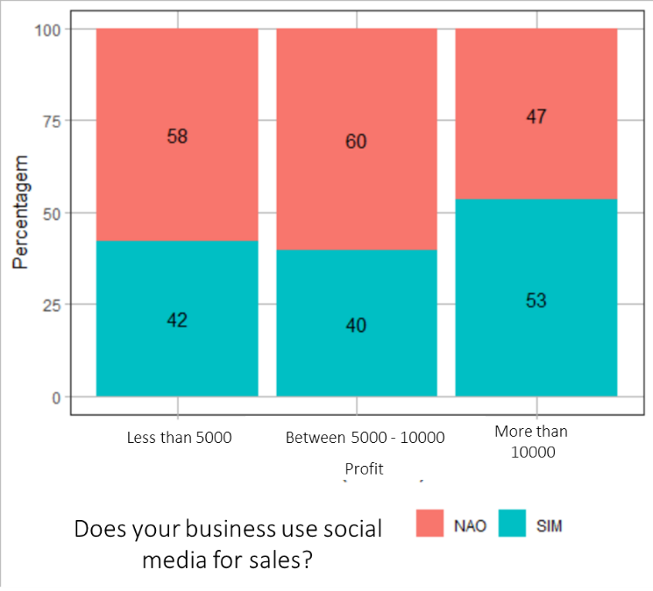

1. The selected businesses’ profile

The selection criteria were defined by MUVA, ANSA and the World Bank Team during a series of workshops following initial research. The goal was to have more structured businesses and be inclusive, acknowledging the entrepreneurial context of the country, especially regarding female entrepreneurs. The figure below describes the selection criteria.

Considering these criteria, from 5,914 entrepreneurs that registered, 2,038 were selected and sent to the World Bank Team. According to Figure 9, the city of Maputo had the higher number of entrepreneurs (918) while Beira had 676 and Nampula 444.

Figure 9: Selected entrepreneurs per city

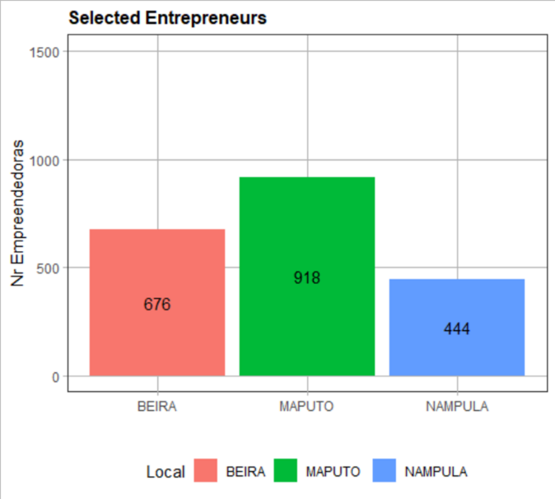

The majority of the businesses were selected because they reported to have more than 2 years of existence and workers. In Beira, 70% of the businesses selected have these criteria, while in Maputo 56% and in Nampula 52%.

Formalized businesses were selected automatically. In Nampula, 32% of the entrepreneurs that registered were formalized while in Maputo and in Beira only 25% and18% respectively met this criterium.

Figure 10 shows that 173 businesses were selected through the combination of two criteria: having more than 2 years of existence and profiting more than 10,000 meticais per month. In Maputo, 11% of the registered businesses met these criteria, while in Nampula 7% and in Beira only 6%.

Less businesses complied with the criteria combination: existing for more than 2 years, having workers and profiting more than ten thousand meticais in the last month. In Beira, only 6% met these criteria, while in Maputo and in Nampula, 8% of the businesses registered had all three criteria, respectively.

In Maputo and in Nampula, only 1% of the businesses showed having exclusively the criteria of workers and profits, while in Beira 0% of the registered entrepreneurs had these exclusive two criteria.

Figure 10: Selection criteria met by entrepreneurs in each city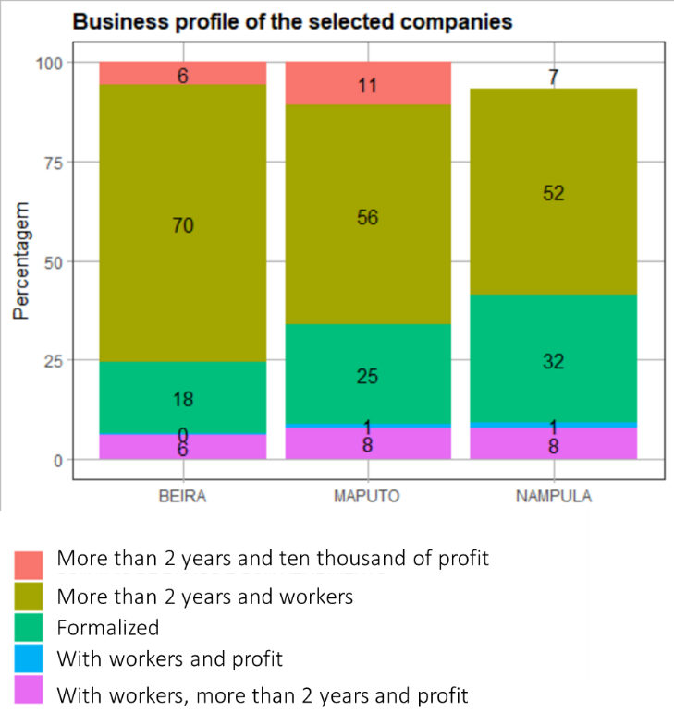

## 3.1 About the businesses’ profits

Similar to the candidates mobilized, the majority of the selected female entrepreneurs reported profiting less than 5,000 meticais in the last month prior to their registration in the Program. According to Figure 11, Maputo is the city that shows the largest number of female entrepreneurs making more profit, with 35% of entrepreneurs profiting more than 10,000 meticais per month and 25% profiting between 5,000 and 10,000 meticais per month. In the city of Nampula, 30% of entrepreneurs profit more than 10,000 meticais while in Beira this number is 22%.

Figure 11: Selected candidates’ Monthly profits per city



## 3.2 The correlation between years of existence and formalization

When we analysed the characteristics of the formalized businesses from the selected entrepreneurs, it is interesting to note that registered and unregistered businesses have the same average of four years of existence. Differently form the candidates in which the profile of formalized businesses were those businesses with more years of existence. The image bellow demonstrates the band of business years of existence with more incidence, with the concentration of formalized businesses from 2 to 8 years of existence and the unregistered ones from 3 to 8 years of existence.

Figure 12: Years of existence and business formalization



## 3.3 The correlation between years of existence and monthly profit

Different from the profile of candidates, the growth of profit doesn’t seem to be linked with the years of existence. The businesses that made more than ten thousand meticais and the ones that made less than five thousand meticais have the same average of business time of existence. The business that made between five to ten thousand meticais of profit in the month prior to the registration in the Realiza Program have an average of five years of existence. The bands from the image below represents the concentration of the majority of business with those characteristics.

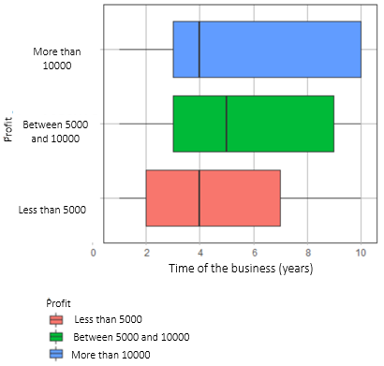

## 3.4 About the businesses sectors

The vast majority of the businesses selected are from the food sector. According to Figure 13, 63% of the business in the City of Beira are from the food sector, while in Nampula this number is 55% and in Maputo 40%. Businesses in the beauty sector are also quite frequent. Beira has 26% of the business selected in this sector, similar to Maputo with 25% and Nampula with 24%.

The “Other” category refers to businesses such as accountants, event organizers human resources, design services and others. Maputo has the higher number of businesses in this category (33%) while Nampula has 17% and Beira only 9%. This might be related to the amount of business opportunities in the city of Maputo and the exposure Maputo’s entrepreneurs have to different kinds of businesses and value chains.

Figure 13: Percentage of business' sectors per city

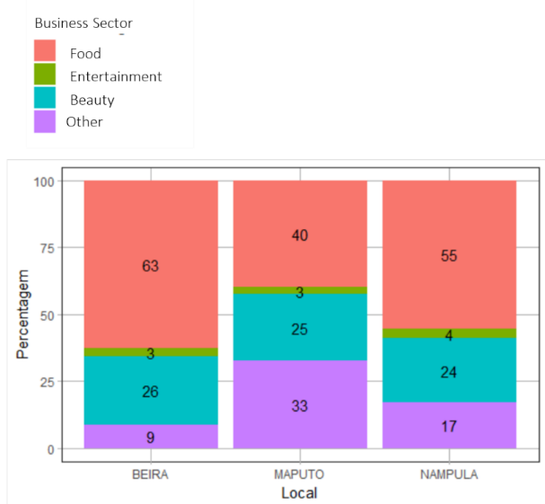

## 3.5 About the sectors and Monthly Profits

Figure 14 shows that the food sector has the highest amount of businesses (45%) that profit less than 5,000 meticais per month, followed by the beauty sector (42%), by the entertainment sector (40%) and by the “Other” category (39%). This could be explained by the variety of businesses in this sector, ranging from catering services, to restaurants, delivery services and to retail of food items and by the larger number of businesses in this category.

On the other hand, the “Other” category has the highest amount of businesses that profit more than 10,000 meticais (38%), followed by the Beauty sector (33%), the entertainment sector (26%) and the food sector (25%). This could be explained by the business diversification and innovation found in the “Other” category.

Another way to look at this data is that more than 50% of entrepreneurs selected, in all sectors, profit more than 5,000 meticiais. The “Other” category having the highest number of businesses profiting more than 5,000 meticais (62%), followed by the Entertainment sector (60%), by the Beauty sector (58%) and by the Food sector (55%).

Figure 14: The correlation between sectors and monthly profits



1. Key strategic considerations for future mobilization

Based on the learnings from the first cycle of the Realiza Program, this report suggest four key strategic considerations for future mobilization:

1. **About the face to face mobilization:** 83.5% of entrepreneurs registered due to our “door to door” approach. For Cycle 2, more resources should be invested in this type of mobilization. Mobilizers are recommended to be trained to be able to identify entrepreneurial profile, basic skills of literacy and numeracy before the registration.
2. **About the online mobilization through social media**: 16,5% of entrepreneurs registered through social media. For Cycle 2, we suggest that the mobilization through social media should be complementary and serve both as a way to enroll and as a way to show commitment, relevance and digital presence, if potential candidates look up for the Program online. Mobilizers will also identify business through social media and approach them in their workplace to present the Realiza Program. In addition, the entrepreneurs from the 1st cycle will be invited to share their successful stories and how the program contributed to their business growth to inspire other potential candidates through social media.
3. **About the mobilization through associations/organizations that work with Mozambican entrepreneurs:** The partnership with institutions that also work with entrepreneurs in Mozambique should continue for cycle 2 with some caveats. Alignment with mobilization partners require greater effort to ensure materials are being disseminated.A recommendation would be to develop a weekly follow up strategy with partners to ensure the message is being spread. The outreach materials should be distributed for them to communicate through their own channels. It is also recommended that the entrepreneurs participating in the 1st cycle could speak about the program in partners’ events.
4. **About the dissemination through radio and television:** Realiza agents, facilitators and entrepreneurs from Cycle the 1st cycle should have a schedule of participation in radio and television programs during the mobilization process to inform present the Realiza Program. In the 1st cycle, only 0,3% of entrepreneurs reported that they knew about the program through this channel and decided to register, however, being present in traditional media is paramount to show to potential candidates that the Program is reliable and that it really exists, an usual concern.

In addition to the mentioned strategies, the second cycle should include motivational sessions embedded in the registration process to assess the entrepreneurs’ commitment with their own business and their interest in the program. The recommendation is for the registration process to have the following structure:

1. Mobilization and registration through channels mentioned above;
2. Business visit for basic literacy and numeracy confirmation;
3. Pre-selection 1 based on the complete registration data, business observation and numeracy and literacy rapid assessment;
4. Motivational day; entrepreneurs will be invited to a online session about entrepreneurship and if she does not show up she will be disqualified and will not continue the selection process,
5. Pre-selection 2 based on the attendance list of the Motivational Day the list of considered resgitration will be develop for the same criteria filtering of Cycle 1;
6. Final list of selected entrepreneurs.